# UML Class Diagram

The class diagram depicts a static view of an application. It represents the types of objects residing in the system and the relationships between them. A class consists of its objects, and also it may inherit from other classes. A class diagram is used to visualize, describe, document various different aspects of the system, and also construct executable software code.

It shows the attributes, classes, functions, and relationships to give an overview of the software system. It constitutes class names, attributes, and functions in a separate compartment that helps in software development. Since it is a collection of classes, interfaces, associations, collaborations, and constraints, it is termed as a structural diagram.

## Purpose of Class Diagrams

The main purpose of class diagrams is to build a static view of an application. It is the only diagram that is widely used for construction, and it can be mapped with object-oriented languages. It is one of the most popular UML diagrams. Following are the purpose of class diagrams given below:

1. It analyses and designs a static view of an application.
2. It describes the major responsibilities of a system.
3. It is a base for component and deployment diagrams.
4. It incorporates forward and reverse engineering.

## Benefits of Class Diagrams

1. It can represent the object model for complex systems.
2. It reduces the maintenance time by providing an overview of how an application is structured before coding.
3. It provides a general schematic of an application for better understanding.
4. It represents a detailed chart by highlighting the desired code, which is to be programmed.
5. It is helpful for the stakeholders and the developers.

How to draw a Class Diagram?

The class diagram is used most widely to construct software applications. It not only represents a static view of the system but also all the major aspects of an application. A collection of class diagrams as a whole represents a system.

Some key points that are needed to keep in mind while drawing a class diagram are given below:

1. To describe a complete aspect of the system, it is suggested to give a meaningful name to the class diagram.
2. The objects and their relationships should be acknowledged in advance.
3. The attributes and methods (responsibilities) of each class must be known.
4. A minimum number of desired properties should be specified as more number of the unwanted property will lead to a complex diagram.
5. Notes can be used as and when required by the developer to describe the aspects of a diagram.
6. The diagrams should be redrawn and reworked as many times to make it correct before producing its final version.

Class Diagram Example

A class diagram describing the sales order system is given below.

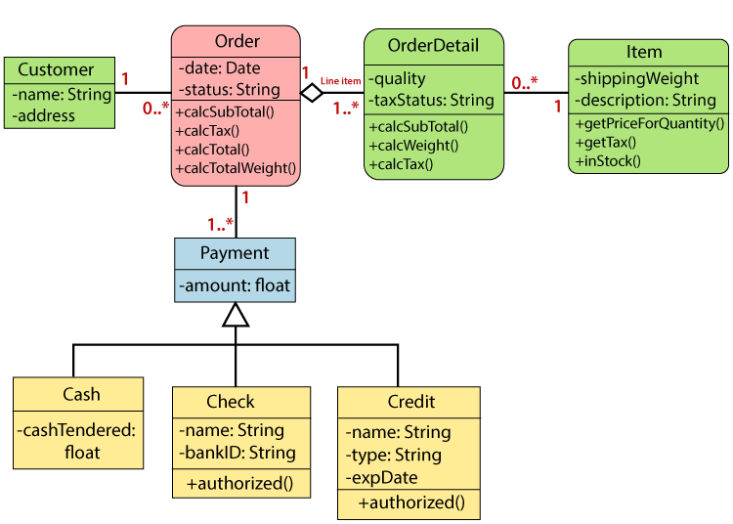

Usage of Class diagrams

The class diagram is used to represent a static view of the system. It plays an essential role in the establishment of the component and deployment diagrams. It helps to construct an executable code to perform forward and backward engineering for any system, or we can say it is mainly used for construction. It represents the mapping with object-oriented languages that are C++, Java, etc. Class diagrams can be used for the following purposes:

1. To describe the static view of a system.
2. To show the collaboration among every instance in the static view.
3. To describe the functionalities performed by the system.
4. To construct the software application using object-oriented languages.

Basic Class Diagram Symbols and Notations

Classes

Classes represent an abstraction of entities with common characteristics. Associations represent the relationships between classes.

Illustrate classes with rectangles divided into compartments. Place the name of the class in the first partition (centered, bolded, and capitalized), list the attributes in the second partition (left-aligned, not bolded, and lowercase), and write operations into the third.

#### Class diagram classes

#### Active Classes

Active classes initiate and control the flow of activity, while passive classes store data and serve other classes. Illustrate active classes with a thicker border.

#### Active class

#### Visibility

Use visibility markers to signify who can access the information contained within a class. Private visibility, denoted with a - sign, hides information from anything outside the class partition. Public visibility, denoted with a + sign, allows all other classes to view the marked information. Protected visibility, denoted with a # sign, allows child classes to access information they inherited from a parent class.

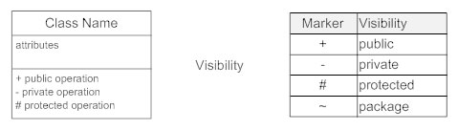

#### Associations

Associations represent static relationships between classes. Place association names above, on, or below the association line. Use a filled arrow to indicate the direction of the relationship. Place roles near the end of an association. Roles represent the way the two classes see each other.

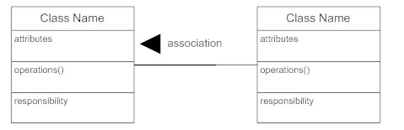

#### Multiplicity (Cardinality)

Place multiplicity notations near the ends of an association. These symbols indicate the number of instances of one class linked to one instance of the other class. For example, one company will have one or more employees, but each employee works for just one company.

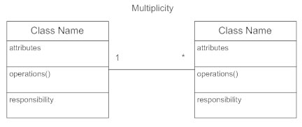

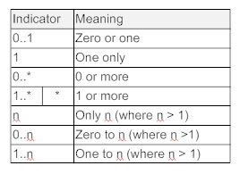

#### Constraint

Place constraints inside curly braces {}.

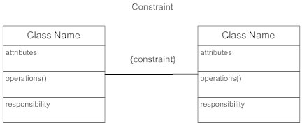

#### Composition and Aggregation

Composition is a special type of aggregation that denotes a strong ownership between Class A, the whole, and Class B, its part. Illustrate composition with a filled diamond. Use a hollow diamond to represent a simple aggregation relationship, in which the "whole" class plays a more important role than the "part" class, but the two classes are not dependent on each other. The diamond ends in both composition and aggregation relationships point toward the "whole" class (i.e., the aggregation).

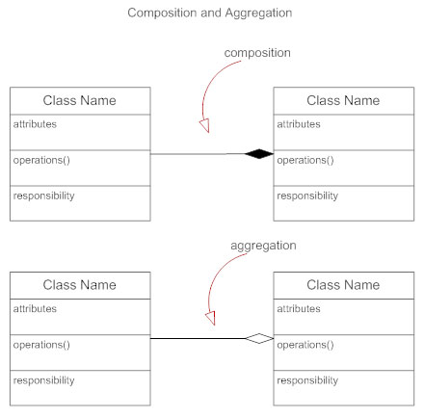

**Dependency**

A dependency is a semantic relationship between two or more classes where a change in one class cause changes in another class. It forms a weaer relationship. In the following example, Student_Name is dependent on the Student_Id.

#### UML Class Diagram

#### Generalization

Generalization is another name for inheritance or an "is a" relationship. It refers to a relationship between two classes where one class is a specialized version of another. For example, Honda is a type of car. So the class Honda would have a generalization relationship with the class car.

